Homework/Pop Quiz #1 of the course: Theory of Computer Games.

1. For the game 2048, estimate its state-space complexity and game-tree complexity. You may state assumptions for the estimation.
2. Prove that for N x (N+1) Hex the longer-side wins.
3. Prove that the theoretical value of Connect(m,n,k,p,q+1) for Black is not worse than that in Connect(m,n,k,p,q).
4. The game Connect(6,2,2) and Hex can both be ultra-weakly solved with no win for White. Please solve the following four positions ultra-weakly. If you think it is impossible to solve it, answer “no” and explain why.

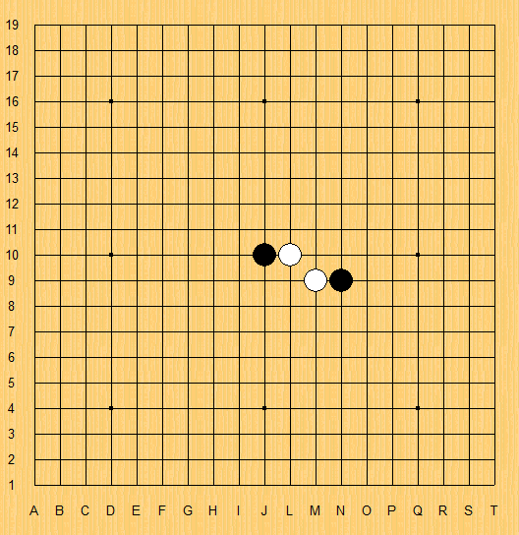 (a) 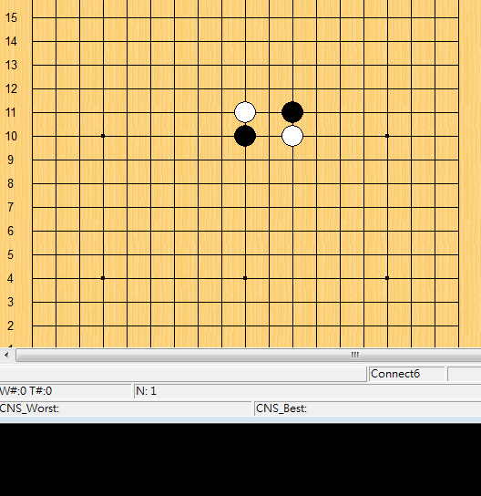 (b) 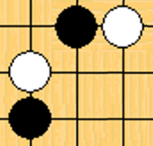 (c)  
 (d)  (e)